### **Introduction to Networks (Version 7.00) – Modules 1 – 3: Basic Network Connectivity and Communications Exam**

**1. Match the requirements of a reliable network with the supporting network architecture. (Not all options are used.)**  
[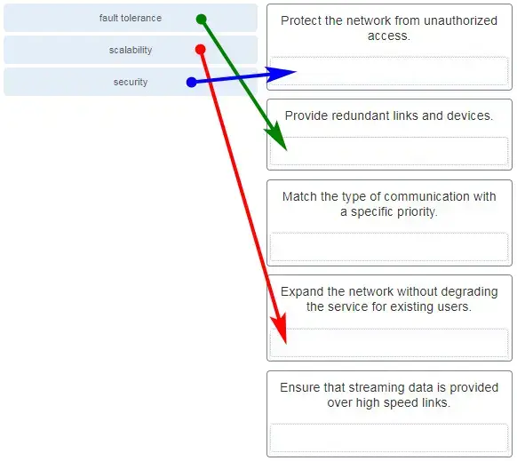](https://itexamanswers.net/wp-content/uploads/2019/12/2020-03-08_181549.jpg)

**2. Match each characteristic to its corresponding Internet connectivity type. (Not all options are used.)**

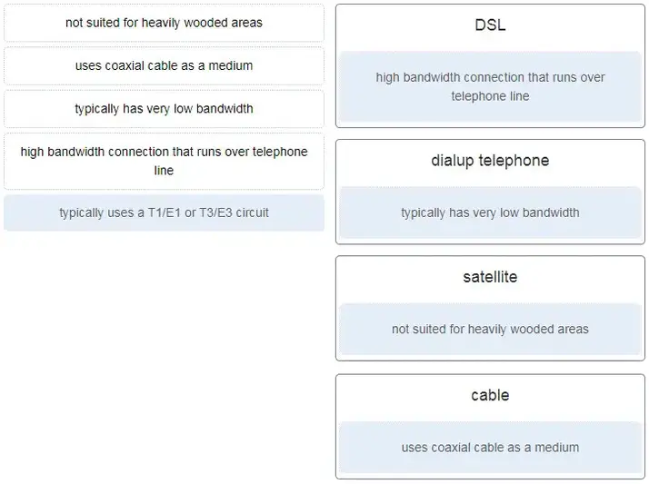

**3. An administrator is configuring a switch console port with a password. In what order will the administrator travel through the IOS modes of operation in order to reach the mode in which the configuration commands will be entered? (Not all options are used.)**

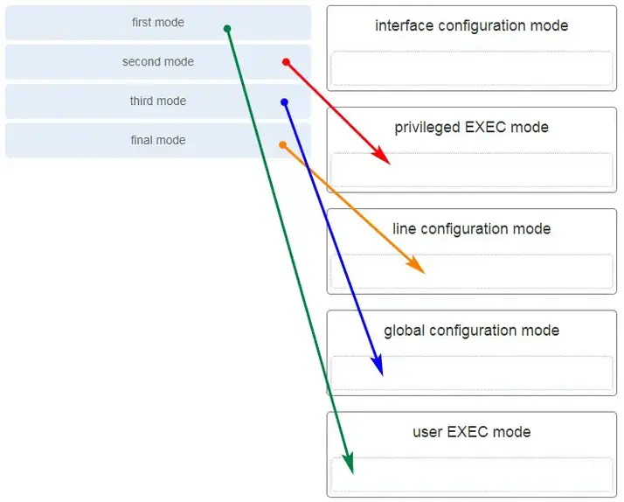

4. **Match the description with the associated IOS mode. (Not all options are used.)**  
[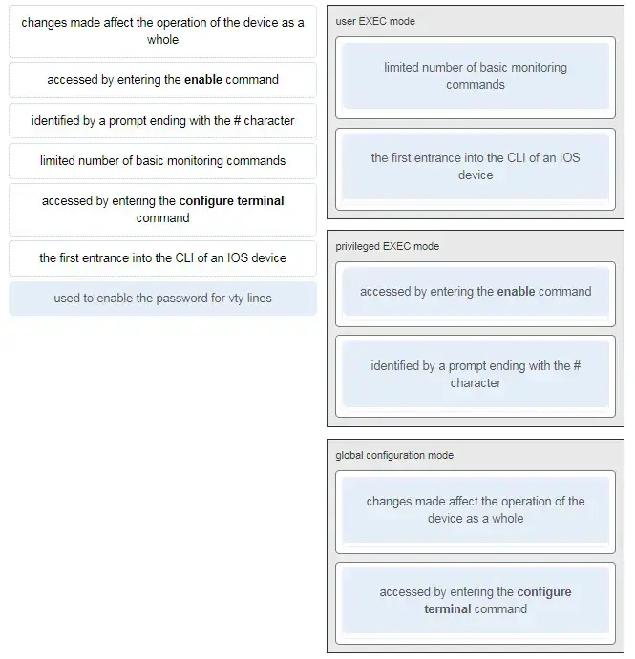](https://itexamanswers.net/wp-content/uploads/2019/12/2020-03-08_184953.jpg)

**5. Match the definitions to their respective CLI hot keys and shortcuts. (Not all options are used.)**  
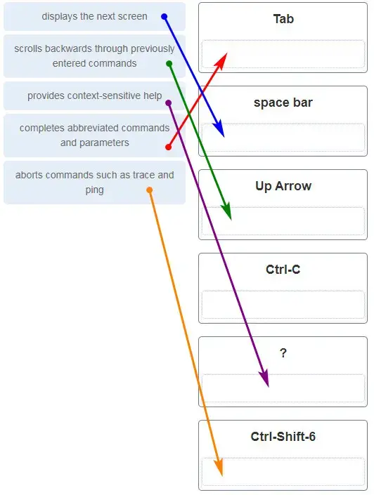

**6. Match the description to the organization. (Not all options are used.)**  
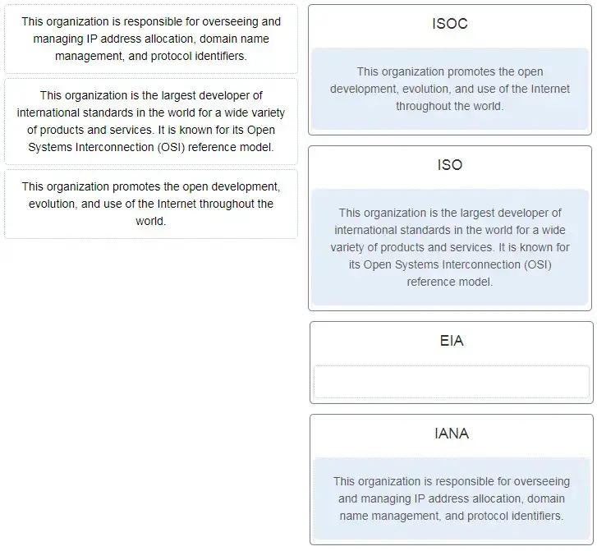

**7. For the TCP/IP protocol suite, what is the correct order of events when a Telnet message is being prepared to be sent over the network?**

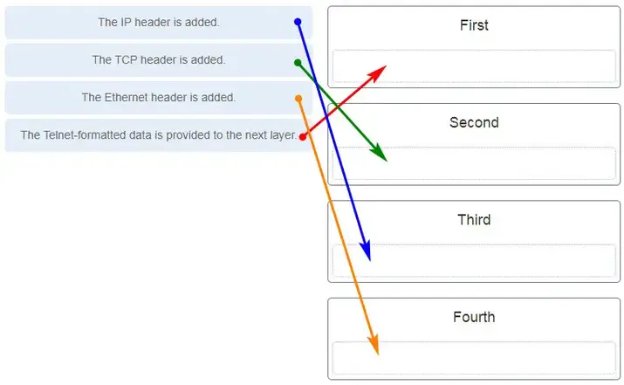

### **Introduction to Networks (Version 7.00) – Modules 4-7**

Match the situation with the appropriate use of network media.

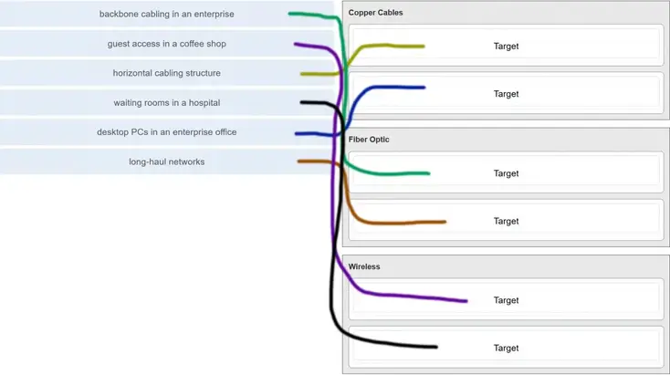

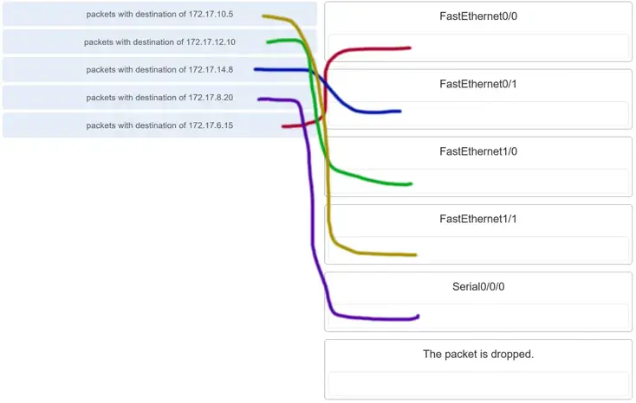

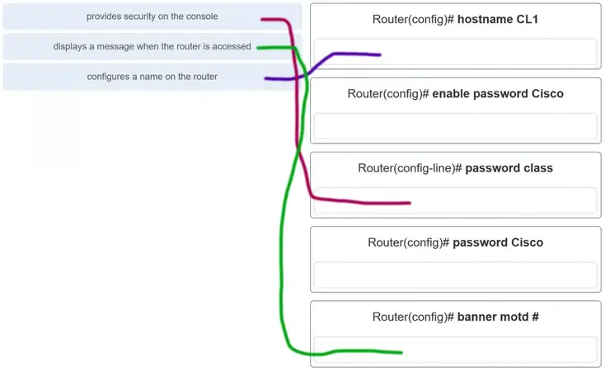

**A network administrator requires access to manage routers and switches locally and remotely. Match the description to the access method. (Not all options are used.)**

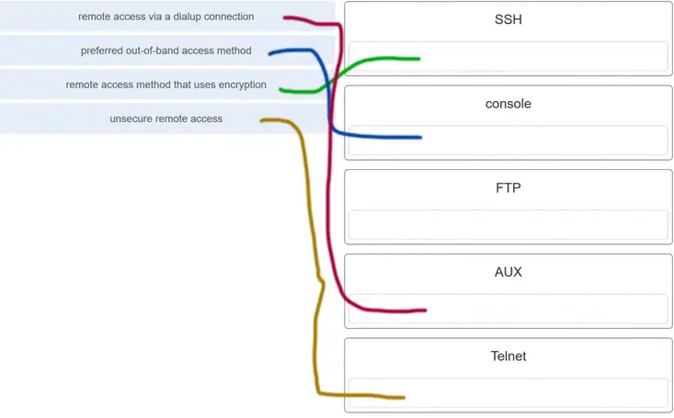

**34. Match the phases to the functions during the boot up process of a Cisco router. (Not all options are used.)**

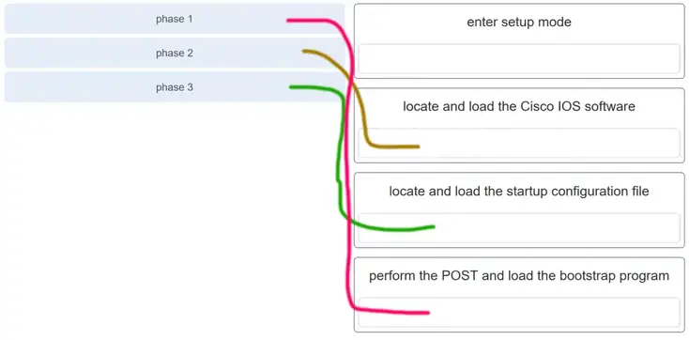

**35. Match the command with the device mode at which the command is entered. (Not all options are used.)**

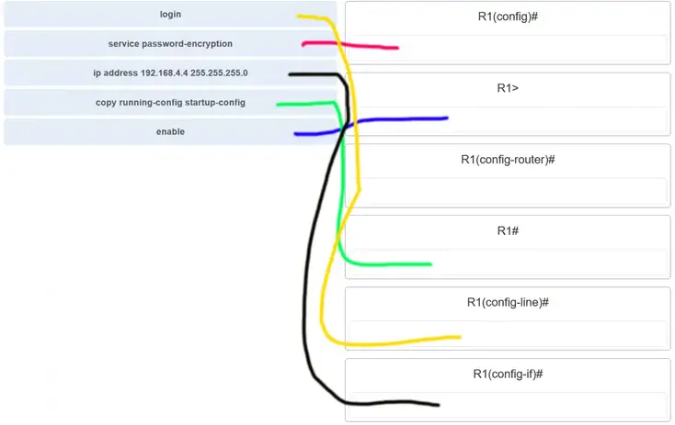

**Match the configuration mode with the command that is available in that mode. (Not all options are used.)**

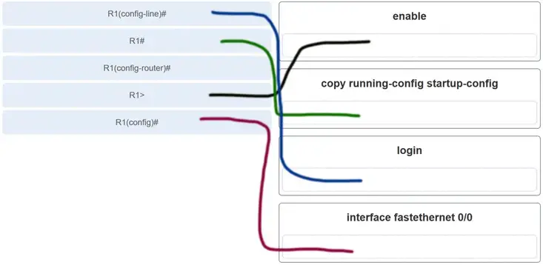

**Explanation:** The **enable**command is entered at the R1> prompt. The **login** command is entered at the R1(config-line)# prompt. The **copy running-config startup-config**command is entered at the R1# prompt. The **interface fastethernet 0/0**command is entered at the R1(config)# prompt.

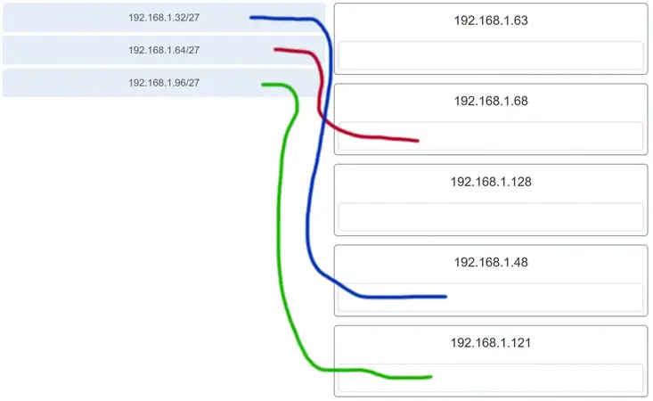

**Match each IPv4 address to the appropriate address category. (Not all options are used.)**

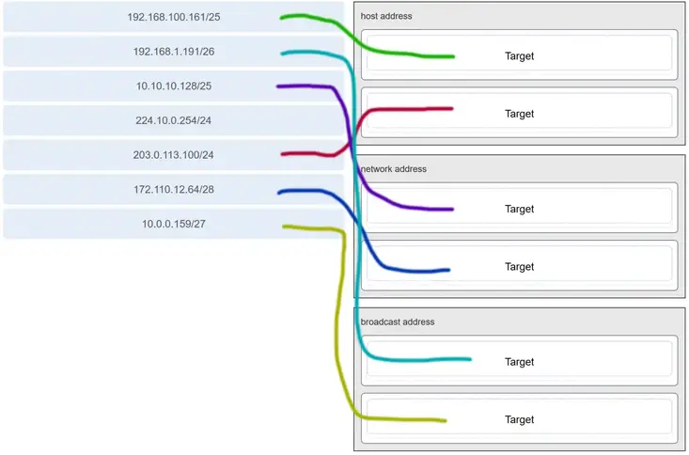

**Refer to the exhibit. Match the network with the correct IP address and prefix that will satisfy the usable host addressing requirements for each network.**

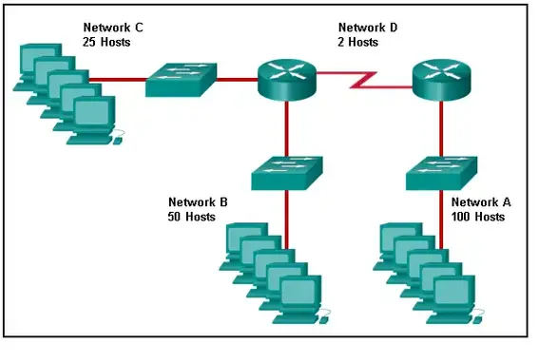

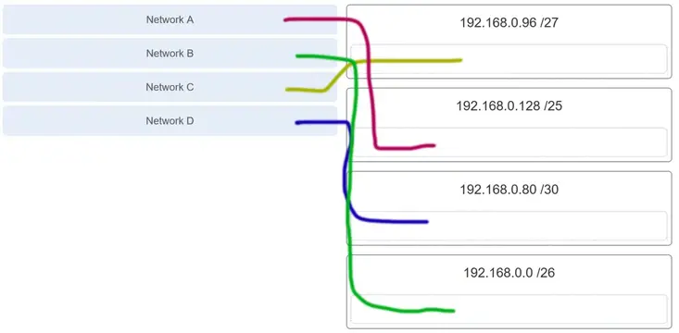

**Explanation:** Network A needs to use 192.168.0.128 /25, which yields 128 host addresses.  
Network B needs to use 192.168.0.0 /26, which yields 64 host addresses.  
Network C needs to use 192.168.0.96 /27, which yields 32 host addresses.  
Network D needs to use 192.168.0.80/30, which yields 4 host addresses.

**Match the IPv6 address with the IPv6 address type. (Not all options are used.)**

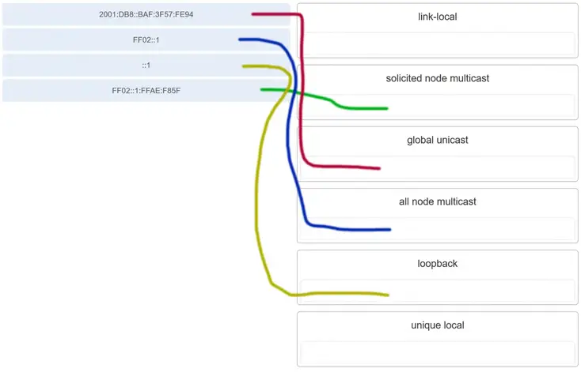

**Three methods allow IPv6 and IPv4 to co-exist. Match each method with its description. (Not all options are used.)**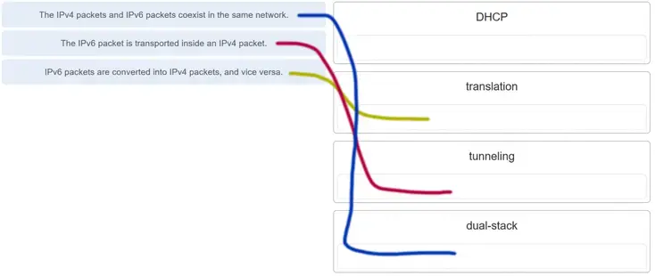

**Match each description with an appropriate IP address. (Not all options are used.)**

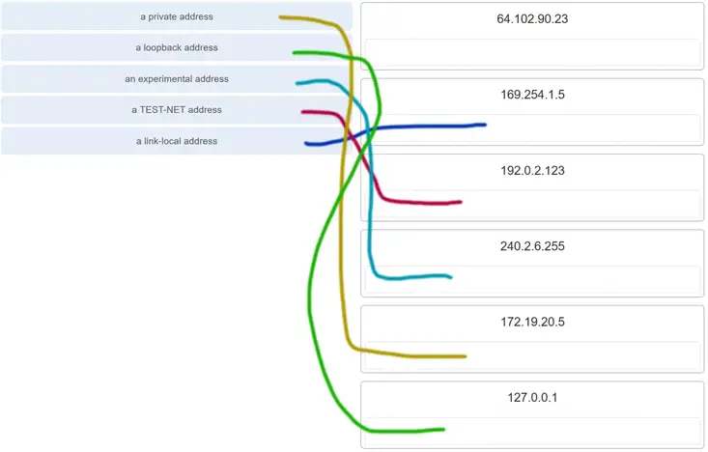

**Match each weakness with an example. (Not all options are used.)**

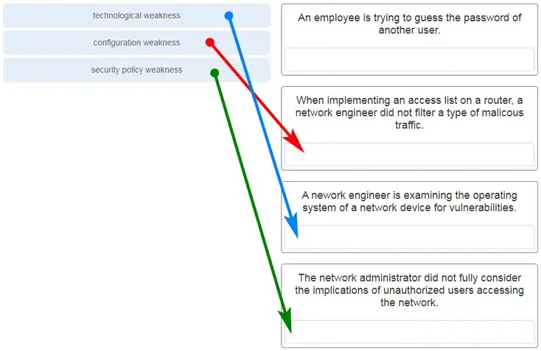

**A client application needs to terminate a TCP communication session with a server. Place the termination process steps in the order that they will occur. (Not all options are used.)**  
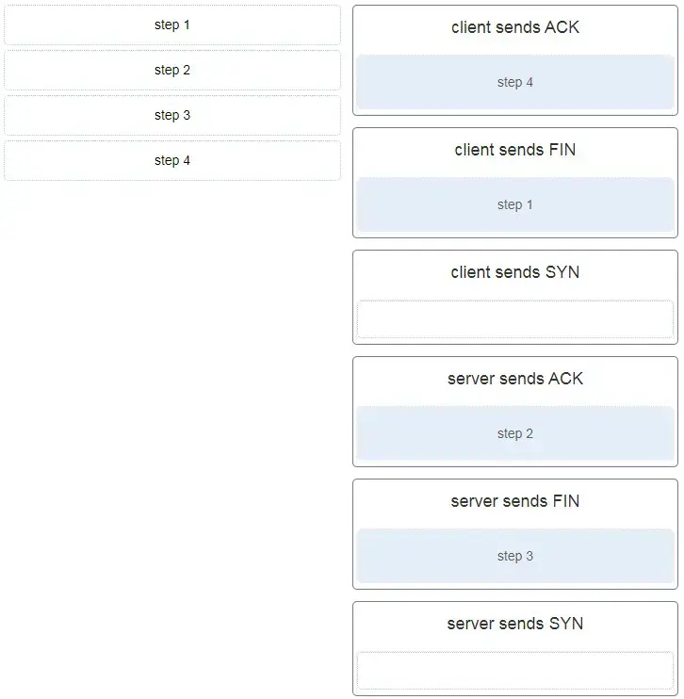

**Match the description to the type of firewall filtering. (Not all options are used.)**  
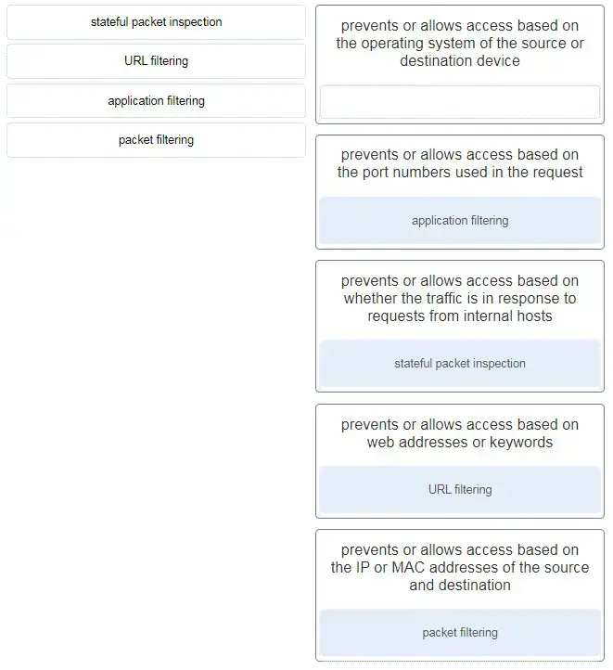

**. Identify the steps needed to configure a switch for SSH. The answer order does not matter. (Not all options are used.)**

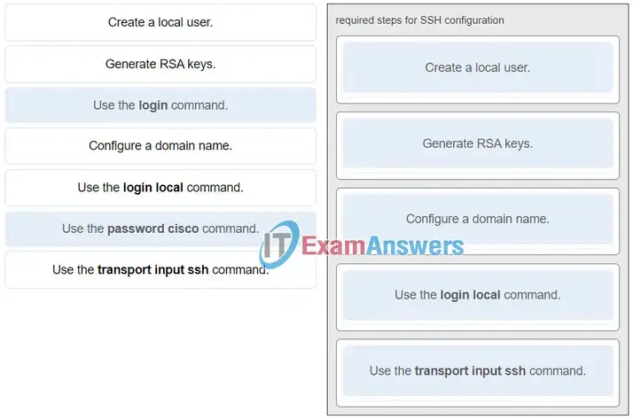

**. Match the characteristic to the forwarding method. (Not all options are used.)**

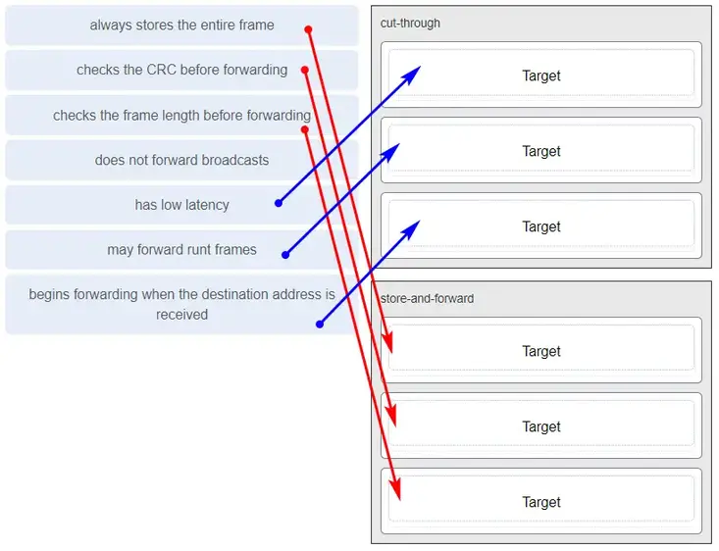

**Refer to the exhibit. Match the network with the correct IP address and prefix that will satisfy the usable host addressing requirements for each network.**

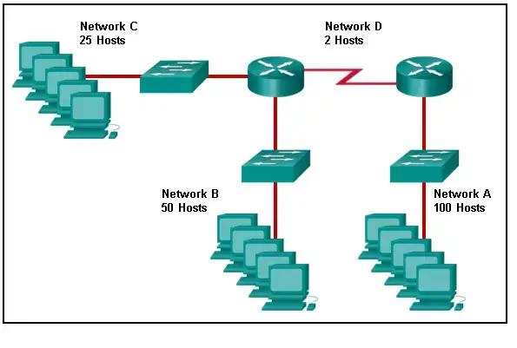

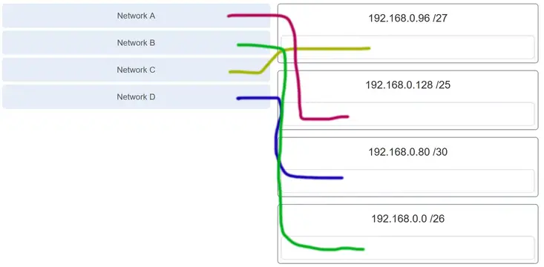

**Refer to the exhibit. Match the network with the correct IP address and prefix that will satisfy the usable host addressing requirements for each network. (Not all options are used.)**  
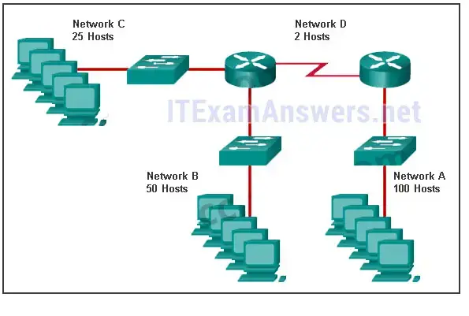

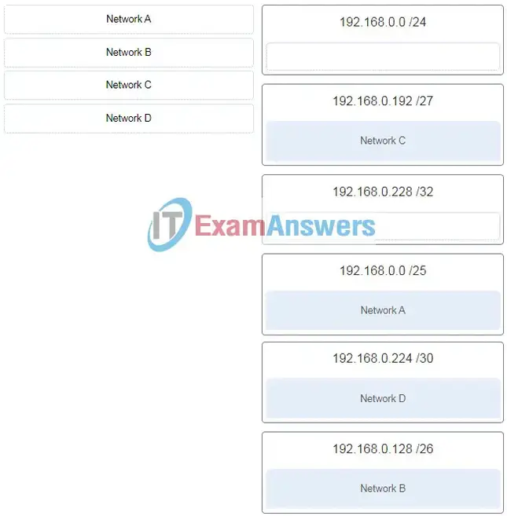

terminal lines) will encrypt all inbound controlled telnet connections.

**58. Match the type of threat with the cause. (Not all options are used.)**

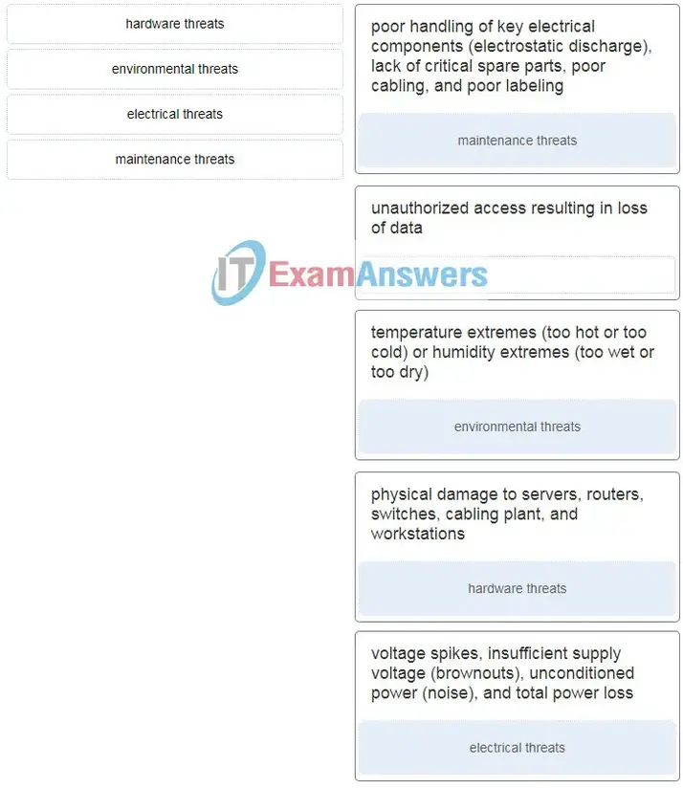

**Match a statement to the related network model. (Not all options are used.)**

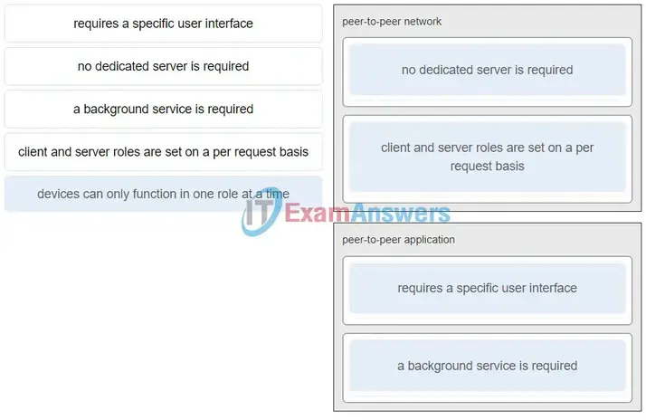

**99. Match each type of frame field to its function. (Not all options are used.)**  
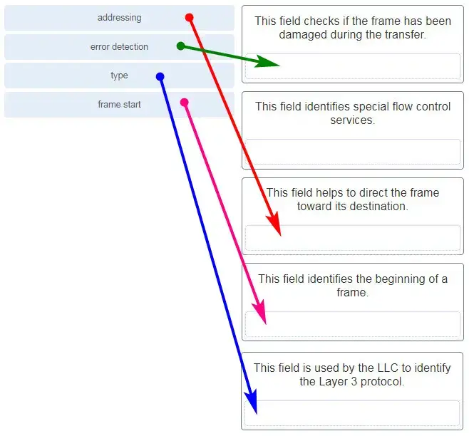

**Match the firewall function to the type of threat protection it provides to the network. (Not all options are used.)**  
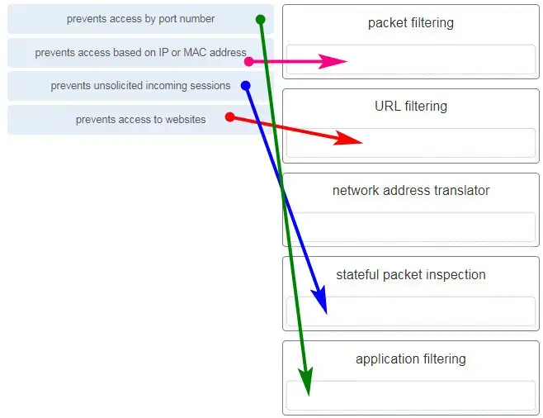

**110. Match the characteristic to the category. (Not all options are used.)**  
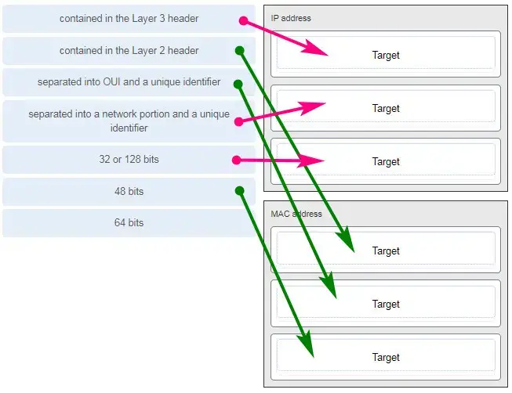

**120. Match a statement to the related network model. (Not all options are used.)**



**Match each description with the corresponding TCP mechanism. (Not all options are used.)**  
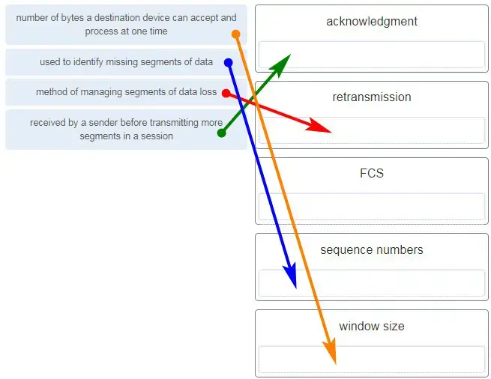

**Match the header field with the appropriate layer of the OSI model. (Not all options are used.)**  
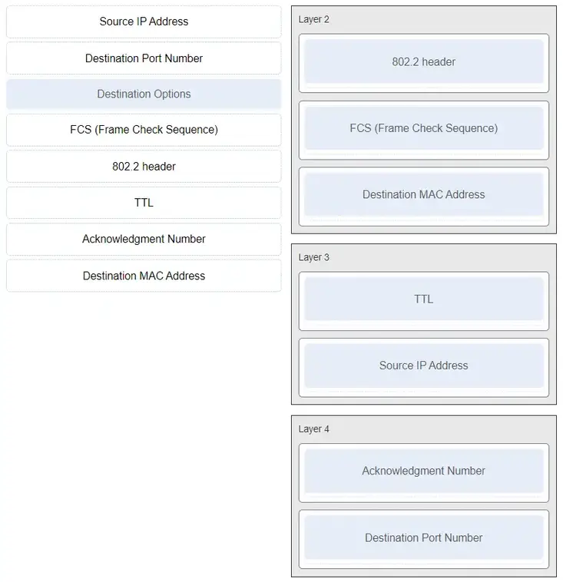

**Match each description to its corresponding term. (Not all options are used.)**  
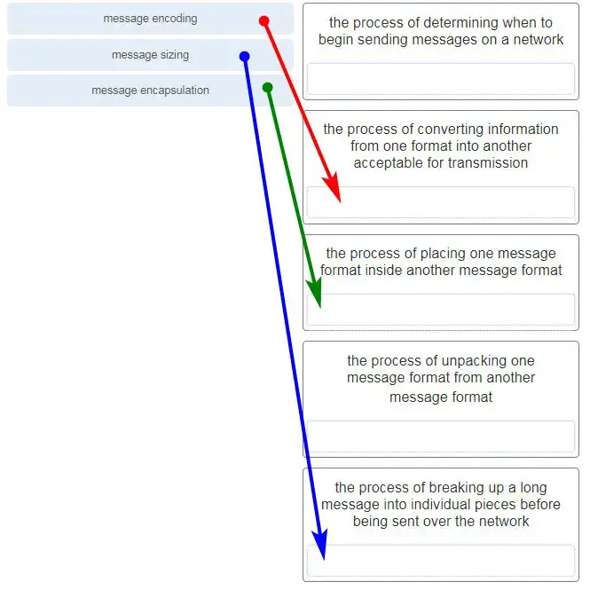

**Match the descriptions to the terms. (Not all options are used.)**  
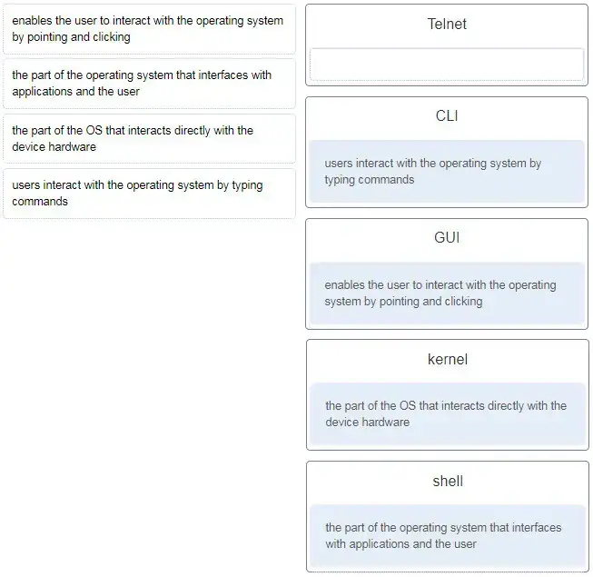

**Match each description with the corresponding TCP mechanism. (Not all options are used.)**  


**Match each item to the type of topology diagram on which it is typically identified. (Not all options are used.)**  
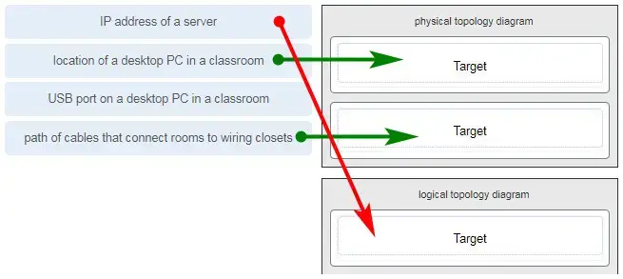

**Match each description with an appropriate IP address. (Not all options are used.)**

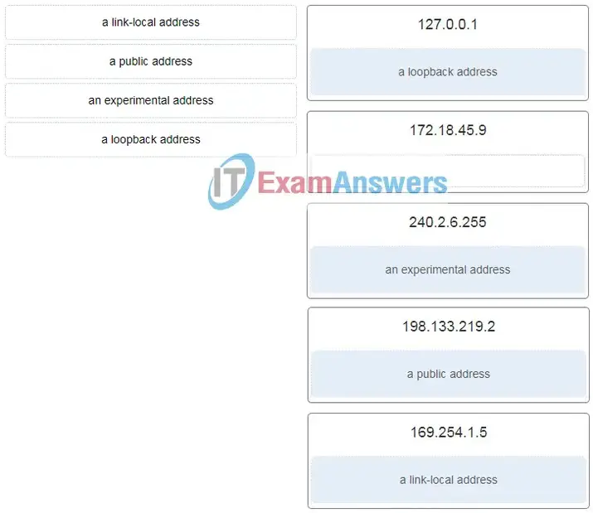

**Match the command with the device mode at which the command is entered. (Not all options are used.)**  
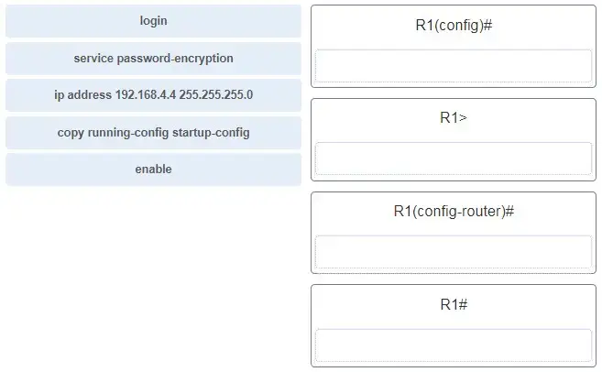  
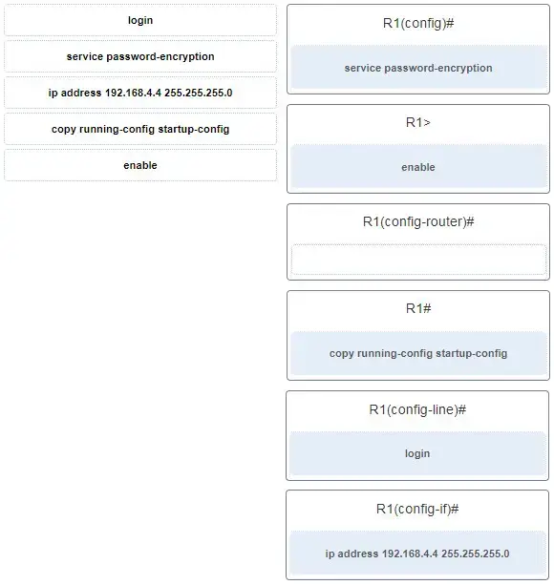

**Three devices are on three different subnets. Match the network address and the broadcast address with each subnet where these devices are located. (Not all options are used.)**

Device 1: IP address 192.168.10.77/28 on subnet 1

Device 2: IP address192.168.10.17/30 on subnet 2

Device 3: IP address 192.168.10.35/29 on subnet 3

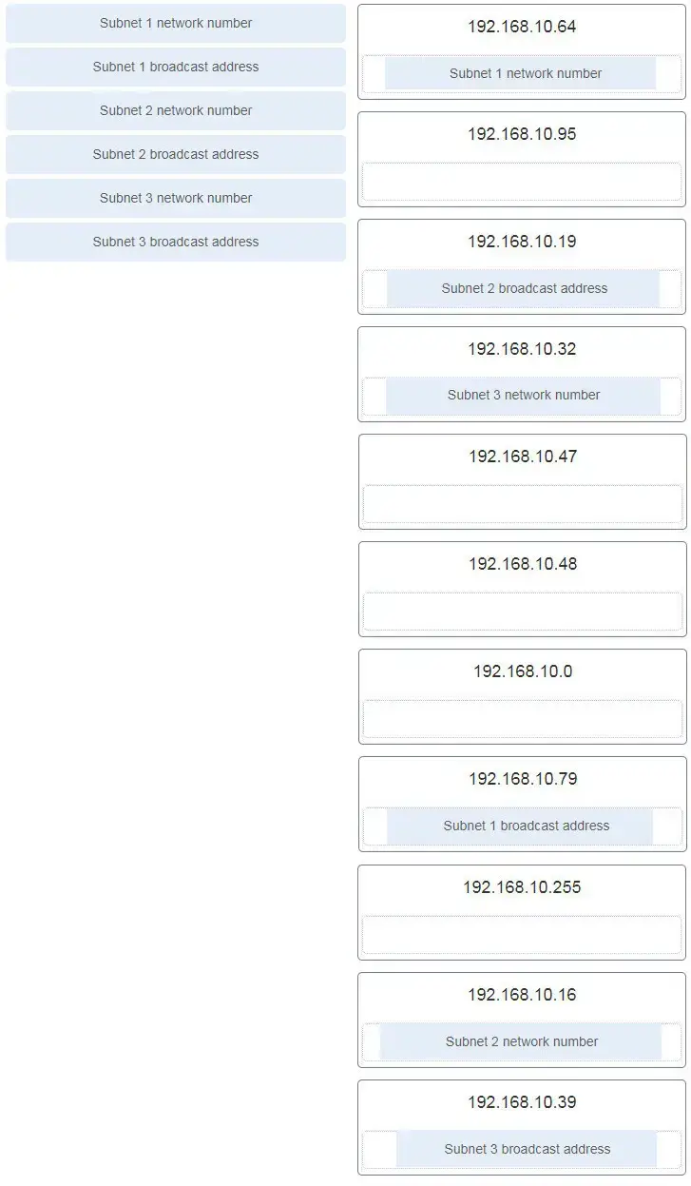

**Match the description with the media. (Not all options are used.)**  
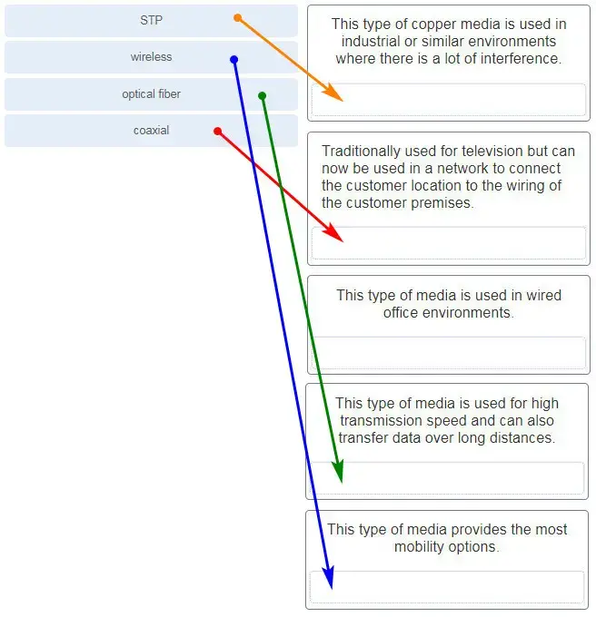

**Match the description with the media. (Not all options are used.)**  
